### Predicting Nation-State Failure

Using open datasets and python, I have created predictive models to forecast the prosperity or failure of nation states in the early 2020’s, based on the geopolitical framework outlined by the bestselling book “Why Nations Fail”.

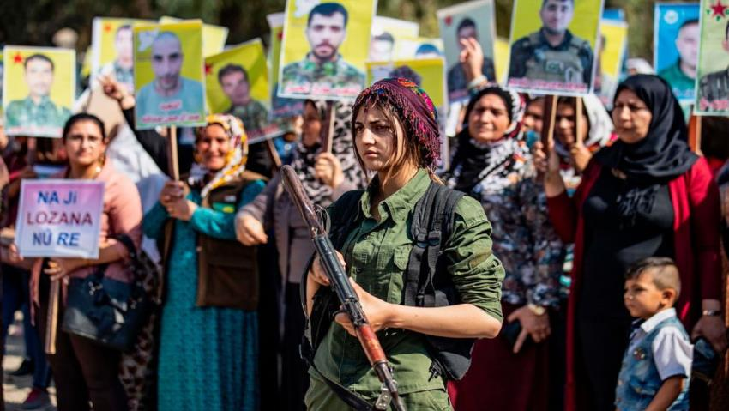

A Kurdish soldier in Northern Syria

In 2011, Tunisia became the first nation in the Arab Spring to peacefully replace it’s dictator with a new democratic regime. It is the only North African nation considered “free” by international non-governmental organizations, and its women enjoy the best reproductive rights in the entire middle-eastern world.

In 2014, the presumably stable Al-Assad regime of Syria disintegrated into a whirlwind of refugees, civil war, and theocratic-sponsored terrorism. This conflict has at times engendered widespread chaos in neighboring Turkey, Iraq, Iran, Jordan, and Lebanon.

In 2009, Costa Rica became recognized as “the greenest nation on Earth”. Slated to become carbon-neutral by 2021, this former Spanish colony enjoys the highest education and lifestyle development levels in Central America, and has politically reconciled massive biodiversity sanctuaries with a prosperous fair-trade agricultural sector.

In 2012, the seemingly burgeoning democratic government of Myanmar tailspun into a genocidal tirade against its Rohingya Muslim minorities; an ongoing situation that also threatens to spread instability into Bangladesh, the recipient of most of Myanmar’s refugees; as well as India and China, who are both also pursuing widespread persecution of their Muslim minorities.

In 2018, Rwanda was found to have the highest gender-pay equity in the world, alongside Iceland, with women earning 94 cents for every dollar earned by a man. Since rebounding quite surprisingly well from its 1994 genocide, Rwanda now regularly has a female-majority in parliament. From 2006 to 2011, poverty rates fell 12 percentage points, and life expectancy rose by 13 years.

The humanitarian orgs, NGO’s, investors, economists, politicians, epidemiologists, and counterterrorism specialists of the world are burning to know: Why have all of these former colonial subjects experienced such radically divergent fates? All are located in the “tropically-cursed”, so-called global south. They are all inhabited by a majority of people of color, in cultural contexts not regarded as “Western”, and experienced decades of chaos and foul leadership in the decades after World War II when they were unbound from the Euro-colonial yoke. Theoretical frameworks of the past would contend that all of these nations should be locked in a cycle of underdevelopment. Yet three of these nations have escaped that cycle. And two of the aforementioned, Syria and Myanmar, descended back into national turmoil just as it seemed they were escaping.

This vexing problem has frustrated the international community’s development efforts to curtail human suffering, stabilize basic markets, negotiate peace deals, unleash human capital, generate unrecognized wealth, contain unforeseen pathogens, and prevent senseless acts of political violence from being formulated in terrorist hotbeds.

In their New York Times and Wall Street Journal bestseller “*Why Nations Fail*”, Daron Acemoglu and James A. Robinson, an economist and political scientist, extend a convincing, historically grounded, parsimonious, and humanizing explanation for the contingent cause of nations diverging into either long-run catastrophe or long-run prosperity: whether the institutions of that nation promote the inclusion of people, or the extractive exploitation of people. I highly recommend book, as it provides to the reader a tremendous amount of clarity about the past, status quo, and future of the world around us. But in the meantime, I will give a brief synopsis of this book, [and link to my former project involving this book, which gives a slightly more elaborated explanation of the book’s arguments.](https://medium.com/@davidadodds/measuring-why-nations-fail-f991fac7e50f?source=your_stories_page---------------------------)

“*Why Nations Fail*” refutes several prevailing theories about the causal factors of nation-state success. Aside from contingent historical randomness, nation and civilizational failure is not caused by the culture of its people, the ignorance of leaders, the geography, climate, or ecology of its location, nor the racial composition of the populace, each of which represent theories that have been common in the last two centuries of academic pondering on this subject, but have gaping flaws in their ability to explain non-conforming historical and modern scenarios. Instead, it argues that long-run prosperity is caused by just three factors:

1. Inclusive economic institutions, as opposed to extractive economic institutions.
2. Inclusive political institutions, as opposed to extractive political institutions.
3. State authority that is centralized enough to stave off anarchy and insecurity, but not so centralized that it engenders totalitarianism and extractive institutions.

### The Phenomena and the Metrics

My last analysis of “*Why Nations Fail*” was to find data that could adequately measure national prosperity, economic inclusiveness, political inclusiveness, and state centrality. Now, I will be using it’s framework to create statistical machine learning models to predict nation-state failure, as well as the future movement of each nation’s prosperity. Since last time, I made three major modifications to the engineering of the original data.

First, I replaced the Happy Planet Index with the Human Development Index as a measure of national prosperity. Though the HPI promises to be a more comprehensive measure of subjective well-being, it is much younger than the HDI. The HPI has taken only 4 surveys composing every nation since 2006, with a major methodology revision occurring in 2011 that changed to time-comparability of the index. However, the HDI, managed by the United Nations, has been standard since 1990, taking a yearly measurement of almost every single nation since. The Human Development Index aggregates its scoring based on metrics of health, longevity, education access, and standard of living. Though it does not include the important attributes of sustainability, subjective well-being, and inequality of outcomes captured by the Happy Planet Index, the HDI’s measurement has been a consistent snapshot of national prosperity for three decades.

Second, I narrowed down the feature metrics, those concerning economic inclusion, political inclusion, and state centrality, to only the most correlated metrics that could be applied to both democratic and dictatorial nations alike. For example, in my last analysis, the fraction of seats in parliament held by women was most strongly correlated with national HPI growth, but this metric fails in nations where elections are fraudulent, or where no parliamentary body exists at all. So the final features are as follows:

* The GINI Index of Income Inequality, to measure Economic Inclusion
* The World Bank’s Political Stability Index and Rule of Law Index, each to measure state centrality
* The Corruption Perceptions Index (Transparency International), the Corruption Control Index (World Bank), and the Voice and Accountability Index (World Bank), each to measure Political Inclusion.

And third, to improve the accuracy of extrapolation, I used sci-kit learn curve extrapolation to extrapolate data points for nations where data-gathering is so difficult, yet so crucial, *because* of state failure events. The time-series interpolation I previously used defaulted extrapolation to the value of the outermost data point, as in Figure 1:

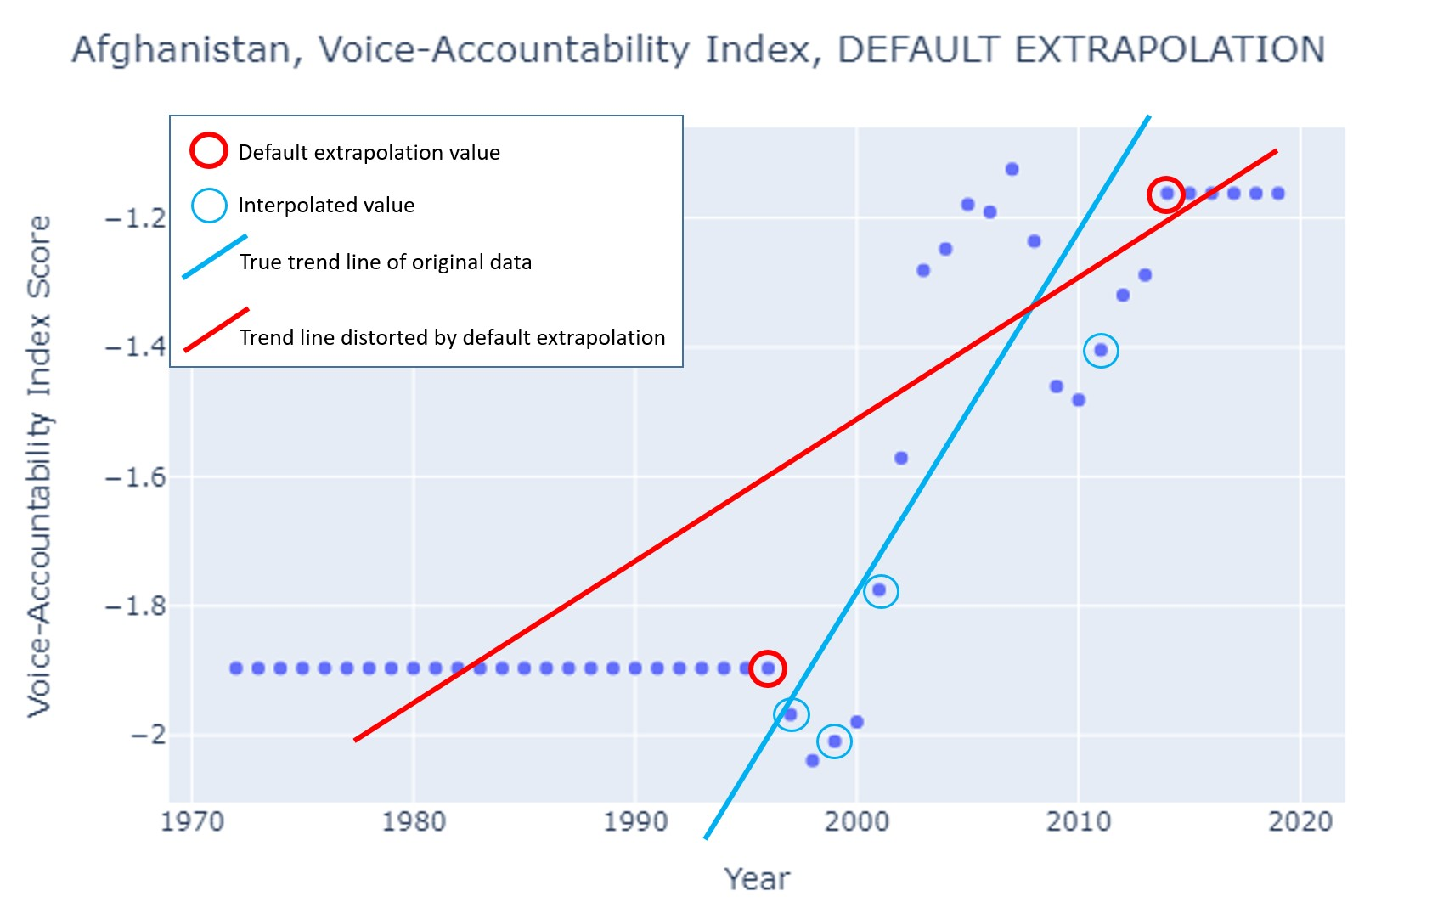

Figure 1: in my prior analysis of metric correlates to national prosperity, default extrapolation distorted trends.

This default extrapolation begets quite a non-trivial distortion in the trend, and values expected beyond, the original data points (1996-2014). In contrast, for this dataset, values were instead extrapolated based on the trend of the originally measured data, like so:

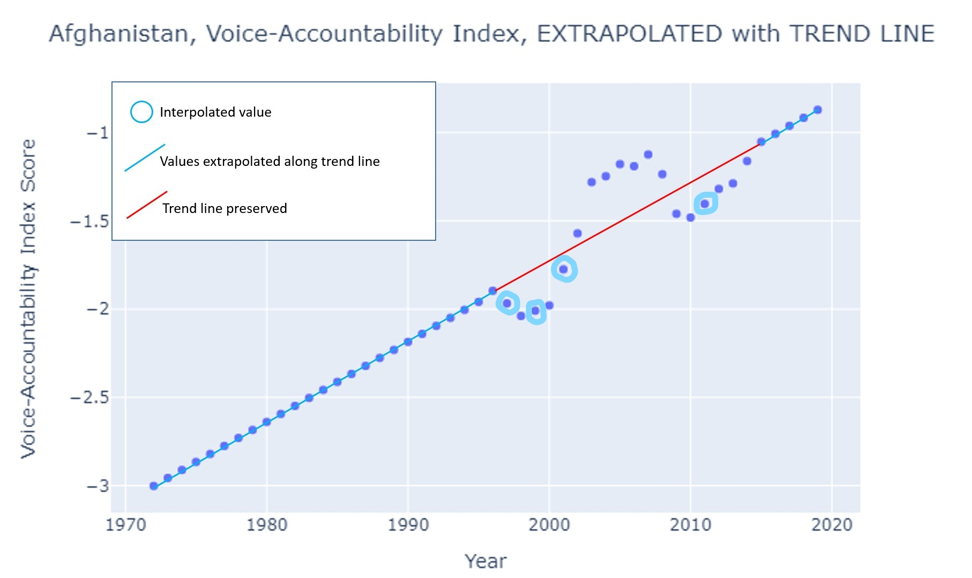

Figure 2: in this analysis Sci-Kit curve extrapolation preserves trends in the same data, and is likely closer to the actual historical data, had it been gatherable.

Being that this predictive analysis lies within the years of 1986-2019, there are now 14 data points in this nation alone that are likely far more accurately estimated than with default extrapolation.

With these interpolations and extrapolations, for each nation, along each of the 6 features, for each year since 1990, the five year trends and five year mean features were engineered and aligned by year. For each observation of the data set, the feature data are trends and means from the past 5 years unto the present, and the target data are trends and means from the next 5 years after year 0.

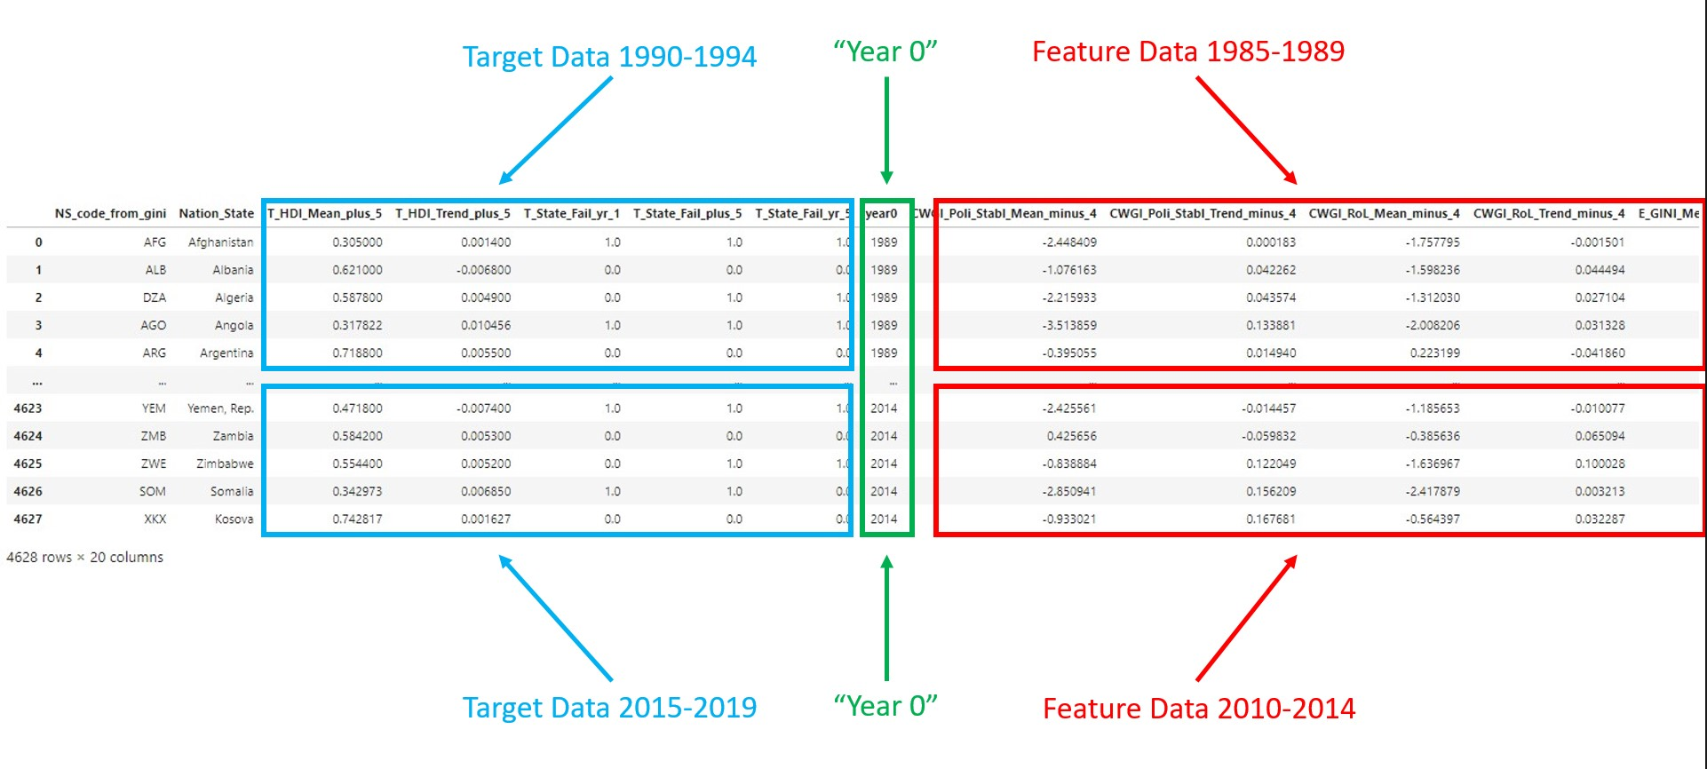

Figure 3: the structure of the final data, before train-validation-test split.

And lastly, coded by hand into the dataset, a binary recording of state failure events occurring in any of the nations in the dataset between 1990-2019. A “1” represents a state failure event that occurred in that year in that nation state, where as a “0” represents the absence of a state failure event. This was engineered into 3 separate target columns: T_State_Fail_yr_1, indicating a state failure event the year after year 0; T_State_Fail_plus_5, a state failure event in any of the next 5 years after year 0; and T_State_Fail_yr_5, a state failure event in the 5th year after year 0.

**What’s a “State Failure Event”, anyway?**

A State Failure Event is any event which constitutes a significant timeframe of a year or several years, and results in the inability of the state to prevent lawlessness or general insecurity for thousands of people.

The scale of timeframe and people effected may seem admittedly arbitrary, and can be tweaked, but an important aspect about state failure events to understand is that a “State failure event” is not necessarily a holistic failure of the state everywhere within its jurisdiction for all citizens. Often, despite the occurrence of a state failure event, the regime it occurred under may continue to outlive the event. Additionally, there are generally individuals, whether in the majority or minority of the citizenry, who may be insulated or relatively unaffected by a tragically chaotic event happening within the same nation.

This insulation could result from individuals being part of privileged elite class. For example, the Mexican Drug Wars may have little impact on wealthy individuals who can afford security provisions, and whose wealth has little to do with the narcotic economy. The Mexican Federal Government is still strong in certain areas, while in other regions it is barely able to contain the chaos.

This insulation could also result from being too poor to be targeted. For instance, during the 2005 Mauritanian coup, mostly political leaders and members of the military found themselves targeted.

The insulation could result from living in a more affluent or stable urban area while chaos descends in more remote locations. The people of Moscow would have noticed little difference in the continuation of law and order during the first and second Chechen, excluding Chechen terrorist attacks.

The insulation could also result from living in a remote location. Again, during the Chechen wars, Siberians also living within the Russian Federation would have noticed little change in the impact of the Russian state in their daily lives.

Common examples of state failure events include, but are not limited to: civil wars, revolutions, insurgencies, persistent terrorism, coups, natural or ecological disasters that lead to prolonged lawlessness (such as drought, famine, earthquake, desertification, tropical storm, or contagion), invasions, genocide, ongoing asymmetric warfare, economic disasters that beget prolonged lawlessness, widespread persistent and deadly civilian protests, violent prolonged territorial disputes, etc.

Some glaring, prototypical examples of state failures in the last 3 decades include Iraq, Afghanistan, and Somalia, who have endured nonstop or almost nonstop armed conflicts, lawlessness, violence, and even occupation.

However, the last 30 years are also full of less known examples of state failure events. The Soviet Union collapsed, precipitating a small coup in Russia in 1993. In the next 2 decades, Russia would also fail to contain armed revolts in Chechnya twice. Mexico, from 2006 to the present, is facing an ongoing drug war. The violence is often infrequent and sporadic, but ongoing, even omnipresent in a few regions of Mexico. Turkey has faced prolonged insurgencies in its western provinces because of its inability to peacefully incorporate its Kurdish minorities into the political discourse. The Phillipines has, in recent decades, experienced prolonged trans-island insurgencies. Violent ethnic conflicts in Georgia, Armenia and Azerbaijan, sometimes spillover from Chechnya.

And notably, North Korea has only experienced about 5 years’ worth of state-failure events in the last 30, when famines occured, because the North Korean state, as repressive as it is, does not often lose authority or cultural cohesion in a way that would technically constitute a state failure. Again, these are *not* events in which the *entire state* has failed. During the Chechen Wars, places such as Moscow, Saint Petersburg, Kazan, etc, were humming along just fine. Law, order, commerce, infrastructure and the like. However, what was happening in Chechnya represents a failure not of the entire Russian Federation, but a failure of the Russian state in the Chechen region for a significant period of time.

To further illustrate the aura of what constitutes a state failure event, several events that occurred in the United States in the last 40 years could have come close to a state failure events:

* The Waco Compound or Rajneeshpuram. If any number of factors had prolonged, for several months, similar levels of the violence or biological attacks carried out by either one of these New Religious Movements, they could have constituted state failure events.
* Similar time-sustained/ spatially-scaled alternatives might have escalated into state failure events from:
* The 1992 Los Angeles Riots.
* The terrorist attacks of 2001.
* The aftermath and lack of response to Hurricane Katrina.
* More widespread municipal or macroeconomic turmoil from the Great Recession.
* It can be argued that the ongoing crisis in Puero Rico, in the aftermath of recent hurricanes and Earthquakes, could constitute a state failure event of the American nation-state.

One perspective is that these events represent an incapacitation of the state; that if only the state were able to retain or swiftly reassert authority over certain events, said event would not constitute a state failure. However, an equally important perspective, which has less to do with state centrality and more to do with political inclusivity, and which is a central assertion of *“Why Nations Fail”*, is that many of these state failure events are the direct result of the state failing to peacefully include the dissenting ideologies within the political processes of compromise, peaceful transitions of power, deliberation and the like.

**Overview of the Data**

Before I consider one of the central questions of this project, I would like to illustrate an example that makes quite apparent the difficulty of predicting nation-state failures, even given the data and the framework laid out by Acemoglu and Robinson in *“Why Nations Fail”*. Figure 4 provides a snapshot of economic inclusiveness in Ukraine since 1960.

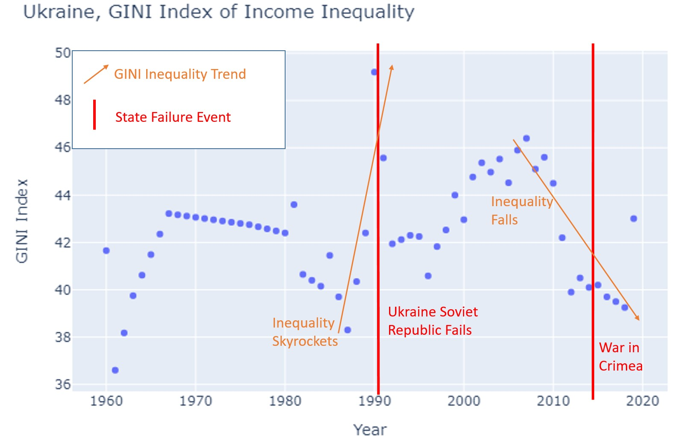

Figure 4: the GINI Index of Income Inequality in Ukraine since 1960, superimposed with 2 major state failure events.

In the late 1980’s, in the wake of the Chernobyl Nuclear disaster, income inequality in Ukraine ballooned, and as we might expect from our theory of institutional inclusion, they experienced a state failure in 1990-91 with the crumbling of the Ukraine Soviet Republic. However, in 2014, on the coattails of the greatest drop in economic inequality in Ukraine’s modern history, the Russian Federation decided to invade Crimea, igniting an ongoing territorial conflict. It was a state failure event largely out of Ukraine’s control, yet a state failure event nonetheless.

A key question of my analysis is whether an amalgamation of these features, indices of political inclusion, state stability, and economic inclusion, when fed into to a statistical model in tandem, can predict state failure events better than a data-educated guess. Do improvements in these metrics beget future increases in Human Development? Can deteriorations in these metrics collaboratively indicate an impending state failure event?

These “educated guesses” form the baselines to beat with predictive models.

* For the HDI trend in the next 5 years, the HDI trend of the last 5 years will be used as the baseline prediction.
* For the HDI mean in the next 5 years, the HDI of the current year (year 0) will be used as the baseline prediction.
* For the three state failure event targets; state failure event next year, state failure event in any of the next 5 years, and state failure event 5 years from now; the presence or absence (1 or 0) of a state failure event in year 0 will be used as a baseline prediction.

|  |  |  |
| --- | --- | --- |
| **Target** | **Meaning** | **Root Mean Squared Error** |
| T_HDI_Mean_plus_5 | Mean HDI of the next 5 years | 0.03012 |
| T_HDI_Trend_plus_5 | HDI growth trend in the next 5 years | 0.004824 |
|  | | |
| **Target** | **Meaning** | **F Score** |
| T_State_Fail_yr_1 | state failure event next year (the year after year 0) | 0.80547 |
| T_State_Fail_plus_5 | a state failure event in any of the next 5 years after year 0 | 0.6685 |
| T_State_Fail_yr_5 | a state failure event in the 5th year after year 0 | 0.49036 |

Figure 5: Baselines for regression of future HDI and classification of future state failure events.

**Models Used and Results**

|  |  |  |  |  |
| --- | --- | --- | --- | --- |
| **Target** | **Model Used** | **Validation RMSE** | **Test RMSE** | **Improvement over baseline** |
| T_HDI_Mean_plus_5 | Multiple Regression | 0.1026 |  | +0.0724 |
| T_HDI_Trend_plus_5 | XGBoost Regressor | 0.002374 | 0.002442 | -0.002382 |
|  | | | | |
| **Target** | **Model Used** | **Validation F Score** | **Test F Score** | **Improvement over baseline** |
| T_State_Fail_yr_1 | XGBoost Classifier | 0.7407 |  | -0.06473 |
| T_State_Fail_plus_5 | XGBoost Classifier | 0.8702 | 0.8523 | +0.1838 |
| T_State_Fail_yr_5 | XGBoost Classifier | 0.6618 | 0.6453 | +0.1547 |

Figure 6: three models beat baseline.

**Findings**

To harken back to my [previous project, “Measuring Why Nations Fail”](https://medium.com/@davidadodds/measuring-why-nations-fail-f991fac7e50f?source=your_stories_page---------------------------), I cannot help but to examine the importance of each feature in predicting state prosperity or failure.

Figure 7: Feature Importances for predicting the trend in future HDI

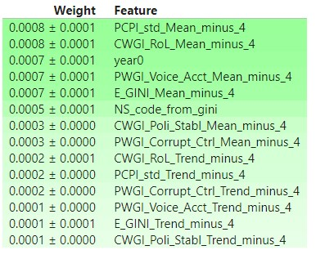

Figure 8: Feature Importances for predicting State Failure Events in any of the next 5 years

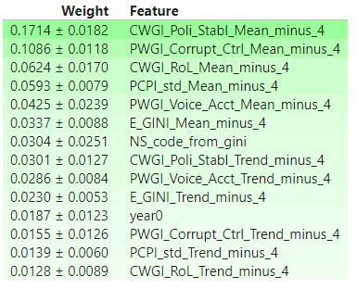

The most discernable pattern from these feature importances is that features engineered as means of the last 5 years are much more predictively useful that features engineered as trends of the last 5 years. I believe that this is because the mean of the last 5 years of a feature, say the GINI coefficient, is able to stabilize away noise in any of the last 5-years’ worth of GINI samples, pushing that mean closer towards what the true GINI value of the whole population during that 5 year period might have been, had we the surveying capacities of a Leviathan. On the other hand, the trend lines, as much as they may reflect actual movement in the GINI index, are likely tainted by reflecting of the noise of the survey quirks and inaccuracies of the last 5 years. So on and so forth for features other than GINI.

Perhaps the trend coefficients of the last 5 years are too narrow to accurately capture the force of movement in national political and economic realities. Perhaps 10 or 15 year trend lines would be more useful for prediction. The data I have allows for 18 year trend analysis for most features, and up to 30 years for the GINI data in particular, which goes back to 1960. But how many years back is too many for capturing the trends relevant to a given nation this year? It is worth re-engineering these features in the future in hopes of finding more optimal trend coefficients. The same is true for mean features.

And furthermore, it is worth noting that the state failure target that was most easily predicted accurately by the baseline educated guess, a State Failure Next Year, was the most difficult to beat with predictive modeling. Even for the state failure target that beat baseline most handily, State Failure in Any of the Next 5 Years, it is worth investigating whether modifying that baseline to include state failure events in any of the past 5 years would make the baseline itself more accurate, possibly rendering a complicated XGBoost Classifier useless.

But without further adieu, the maps forecasting the performance of Earth’s nation states in the early 2020’s:

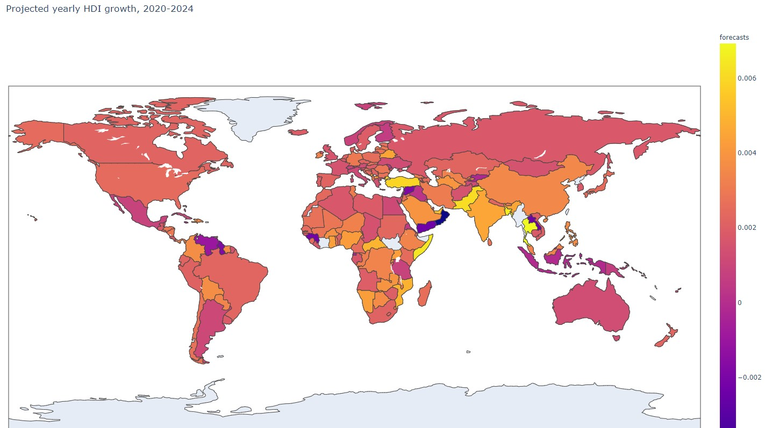

Figure 9: A snapshot of which nations’ citizens will experience increased prosperity. Yellower shades will see the fastest growth in HDI, Darker Blue shades the fastest degradation of HDI, and nations closer to Magenta staying more or less the same in terms of HDI.

Four nations are notable surprises in Figure 9:

* Norway and Finland are projected to have no growth or contraction in HDI. This may be because there is theoretically only so developed living standards can become, but the framework laid out by Acemoglu and Robinson would contend that their political and economic inclusiveness, which is off-the-charts, would propel them to even further breakthroughs in living standards and well-being, rather than no dynamism. Only 2025 will tell.
* Thailand and Somalia are surprising as well, especially given that the next map predicts them both to experience state failure events in the next 5 years. However, Acemoglu and Robinson do note that growth, sometimes even rapid growth, is possible under extractive institutions, usually if two conditions are present. First, that there is considerable catching up to do with more advanced nations elsewhere, who have more advanced technologies and systems yet undeployed in the underdeveloped nation. This is certainly the case for both Thailand and Somalia. But second, growth under extractive institutions historically almost always depends on the presence of a strong centralized state authority. Thailand may be close to having this, but Somalia is not. Only 2025 will tell!

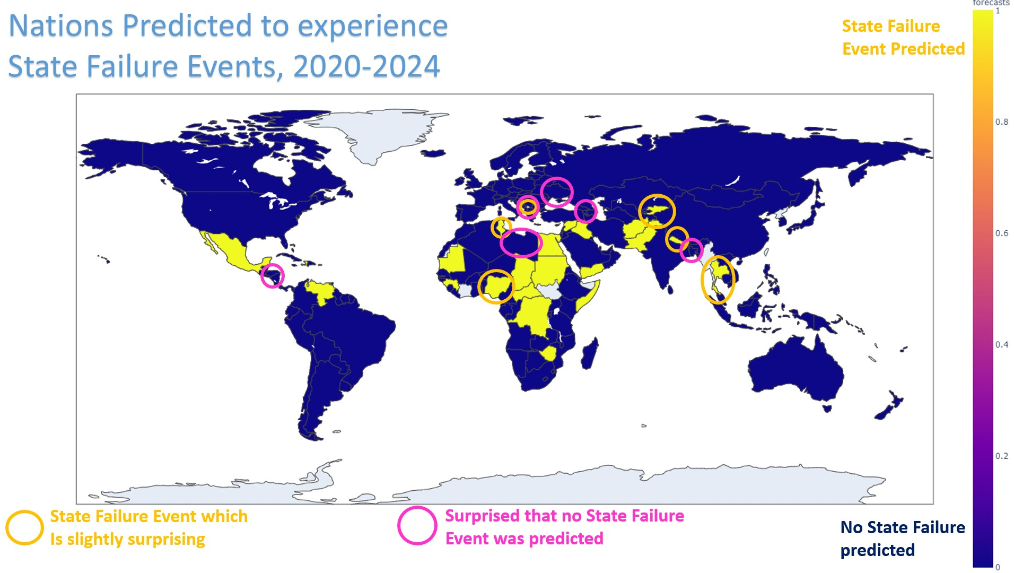

Figure 10: A forecast of which nations’ are predicted by XGBoost to experience a state failure event in the early 2020’s.

For this map, I have circled which nations are surprises. First, let us discuss the nations that I am (slightly) surprised are predicted to experience a state failure event:

* Nigeria is the largest democracy in Africa by population, with an impressively low debt-to-GDP ratio of 11%, approximately 10 times better than the national debt burden of the United States, for example. They have also been one of a handful of nations to welcome in a burgeoning African tech industry, largely without dependence on IMF or Chinese development aid. However, 2 factors could contribute to swift deterioration of stability in Nigeria. First is the curse of natural resource wealth, of which Nigeria has a ton from oil reserves. Natural resource wealth can lead to a tyranny of an economic elite with oligopolistic control of said resource, which reduces political dependence on human capital and begets extractive institutions and instability; especially if global dependence on oil continues to shrink because of renewable energy sources. Secondly, Nigeria has long standing ethnic tensions between English speaking populations and French speaking populations, and likewise religious tensions between Christians near the coast and Muslims inland. Incorporating these often hostile groups into ongoing peaceful political discourse has been a turbulent struggle for decades.
* Tunisia is known for being the nation of North Africa most respectful of political and civil rights, a mark of strong levels of institutional inclusiveness. They were the first nation in the Arab Spring to replace their dictator with a democratic regime, and perhaps also the nation that did it the least tumultuously. So it comes as a surprise that the model is predicting a state failure event in Tunisia. However, the virtuous cycle into prosperous democratization is not always smooth, and is often marked by the stumbling of “2 steps forward, 1 step back.” Perhaps the shadows of their recently deceased dictatorship, and other instabilities in the Middle East, could cause a state failure in Tunisia.
* Kosova is a slight surprise, given that it was one of few former Yugoslav nations that split from the Serbian bloc via a peace agreement in 2008. But perhaps tensions in the neighboring Montenegro, which is still roiling to officiate its independence from Serbia, could spill into Kosova.
* Kyrgyzstan seems to have stabilized after more than a decade passing since the conclusion of its civil war, and it is perhaps more surprising that its more repressive neighbor Uzbekistan is not also forecast to experience a state failure event. However, spillover from Taliban and other terrorist activity in Afghanistan, water conflict between Pakistan and India in Kashmir, and China’s continued persecution of its Uighur Muslims in Tibet could trigger any number of instabilities in Kyrgyzstan. But wouldn’t they also create turmoil in neighboring Tajikstan, which is even closer to all 3 of these conflicts? And yet Tajikstan is not predicted by the model to experience a state failure event.
* Nepal is surprising simply because of its reputation as a peaceful, Hindu / Buddhist, inland Himalayan mountain nation; a neutral “Switzerland of the Himalayas”. However, it is not as conscientious as Himalayan neighbor Bhutan, which is famous for prioritizing GNH, or Gross National Happiness, over GNP. Nepal has experienced two brief civil wars since the turn of the millennium, and is a hotbed of trans-Asiatic human trafficking, both issues which are still simmering underneath what seems to be recent stability.
* And Thailand, as discussed, is forecast not only by my models to experience the most rapid growth in HDI, but is among a handful of nations in the past few decades that regularly experiences tremendous double-digit economic growth (GDP growth rate). However, it is possible that the ongoing genocide and refugee crisis in neighboring Myanmar, as well as particularly disastrous tropical storm seasons, could ignite serious problems in Thailand.

And now, let us discuss the nations that I am (slightly) surprised are predicted to ***not*** fail:

* Honduras is currently the epicenter of the Central American refugee crisis, resulting from the political dominance of gangs in its urban centers, the trafficking of drugs northward from South America, and the transit of Venezuelans fleeing the failing state. Honduras is not handling these pressures as well as its neighbors are.
* Libya, which just recently ended its civil war, has 2 neighbors more stable than itself predicted to experience state failure events: Tunisia and Egypt. Libya is not only vulnerable to the institutional remnants of its recent authoritarian past, but also the natural resource curse of oil wealth, as was mentioned with Nigeria.
* Kosova is predicted to fail, but none of its neighboring nations are as well. Kosova lies in a region of Europe that is known historically as “the Balkan Powder keg”. Ottomans and Byzantines clashed here in the middle ages. World War 1 started in this region. Ethno-religious conflicts between Muslim minorities and orthodox Slavs precipitated the genocide in the Balkans in the 1990’s. If Kosova is predicted to experience a state failure event, why not also Montenegro, who is still angry over its short-lived and recently revoked nationhood recognition by the international community.
* Ukraine is still fighting a low-grade, simmering, at times proxy, war with Russia over Crimea. Russia also seems poised to retake more regions of Ukraine on a whim, and yet Ukraine is not predicted by this model to experience a state failure event in the early 2020’s.
* The Caucuses States seemed to be roiled by the overflow of conflict in Chechnya at least once per decade since the fall of the Soviet Union. And yet the model predicts no state failure events in the region. This is a surprise concerning not only Georgia, Azerbaijan, and Armenia, but also Russia, which has not satisfyingly resolved political tensions in Chechnya, despite 10 recent years without war, and is becoming increasingly spread into military conflicts in Ukraine and Syria.
* Bangladesh briefly experienced both a violent coup and a famine in the last 30 years, and it is bearing the brunt of the Rohingya refugee exodus from the genocide in Myanmar. Despite the publicity of the war in Syria, the refugee camps in Bangladesh are currently the world’s largest. Myanmar’s other neighbor of Thailand is predicted to experience a state failure event by the model. But Bangladesh, who is directly adjacent to Myanmar’s Muslim regions, is not.

**Moving Forward**

The next most obvious step to improve these models to craft an algorithm that can beat baseline educated guesses for State Failure Events Next Year, as well as the Mean Expected HDI for each nation in the next 5 years. In terms of demonstrating Acemoglu and Robinson’s assertions with data, the next move would be to find data that adequately measures the old theories of national prosperity and state failure: prevailing cultural origins, the ignorance of leaders, geography, climate, and ecology, and the racial composition of the populace. If models based on these national attributes fail to predict prosperity and state failure events any better than attributes that measure institutional inclusiveness, as *“Why Nations Fail”* purports, then it at least lends some datagenic credence to Acemoglu and Robinson’s theory.

Another gnawing next step would be to try to predict two other crucial geopolitical events: democratic transitions and dictatorial transitions. These events, which directly ease or emburden the daily lives of citizens, often happen in the absence of state failure events, and can be strong long-run predictors of future prosperity or nation state failure, if Acemoglu and Robinson’s Institutional Theories are correct. This would involve careful analysis of the recent history of every nation in modern history to hard-code each nation in each year as a democracy or a dictatorship, and/or deployment of any pre-existing political science metric devices for grading nations along the dictatorship-democracy spectrum, which might allow for a regression. But political scientists also often question whether democracy inherently begets prosperity, especially in a world of pervasive corruption and election fraudulence. Acemoglu and Robinson would argue that it does, but I have yet to be investigate this with data or prior research review.

And lastly, teasing out causation would be the epitomic result of this empirical data analysis. Does institutional inclusiveness *really cause* future prosperity? If so, we be that much closer to developing a successful “secret sauce” for the ever elusive holy grail of global development. Teasing out causation, however, in a world without truly controllable social experimentation or windows into divergent dimensions, necessitates the deployment of complex econometric tools, and often the dumb luck of being able to gather data observing a contingent event that happens to split two very comparable population cohorts into divergent trajectories. Hopefully hard work and scientific vigilance can leave it less to dumb luck.

May peace prevail on Earth.

https://medium.com/@davidadodds/predicting-nation-state-failure-abf3793c7d6b?sk=bda61c06ac7cca4fac748d3c74c58300